**Mitsubishi Air Conditioner**

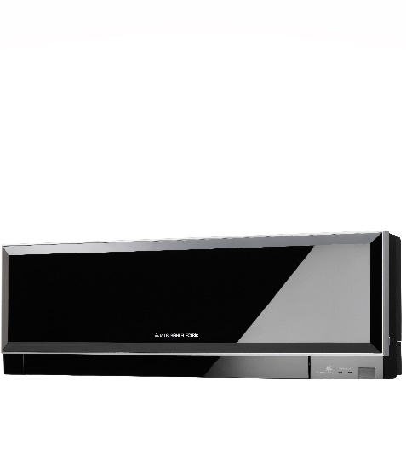

**Key Features** Brand warranty  
 “Vertical airflow” provides powerful floor level heating  
 “Horizontal airflow” does not blow cool air directly at the occupants in the room  
 Air conditioner filter features " Ion Deodorization Filter " & "Apple-catechin Filter "  
 Flexible Installation  
 Max. Piping Length Horizontal 30 Meter **Metalic Body Price per Unit: $750/-**

**CORPORATE OFFICE**

    1300 E. Control Tower Rd.  
    Suite 216 Block L3  
    Englewood CO 80112  
 Phone: 720.974.7878  
    Toll Free: 1.877.929.7878  
    Email: [info@choicescreening.com](mailto:info@choicescreening.com)